Channel

# java.nio.channels包介绍

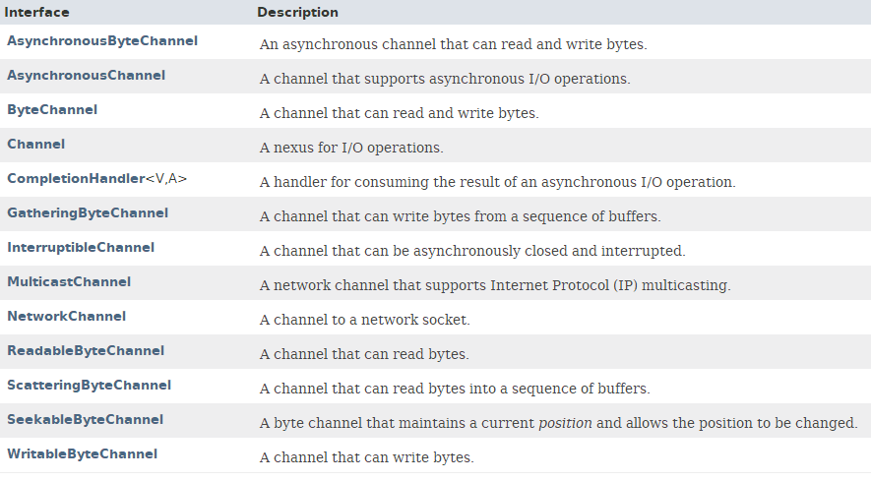

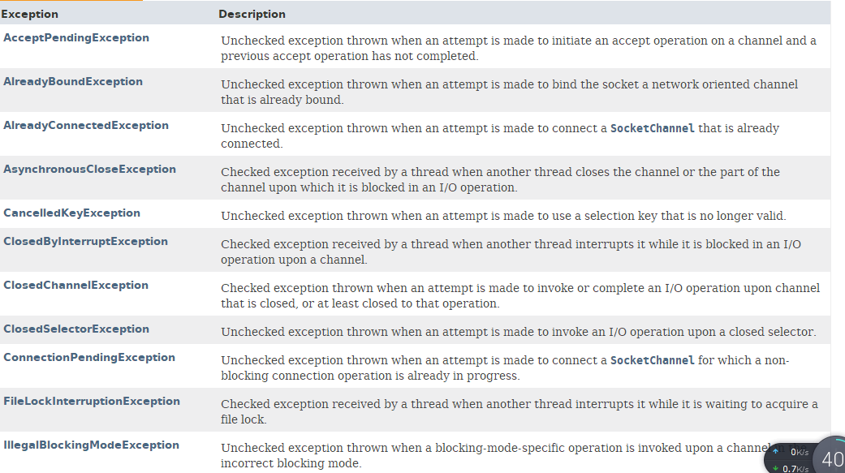

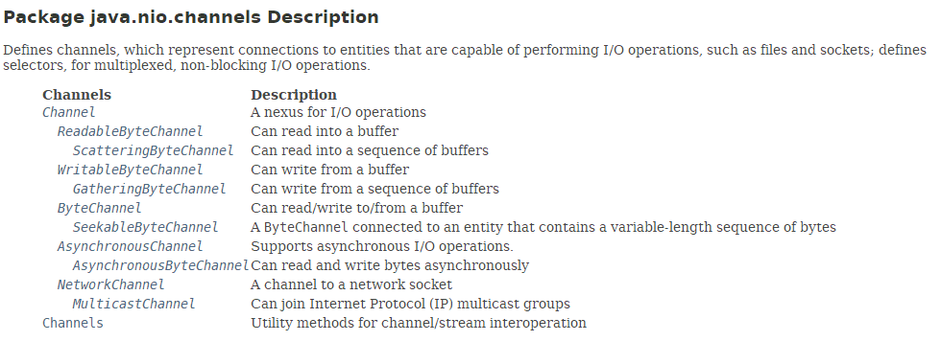

# Channel接口

## 继承关系介绍

**java.nio.channels.Channel**

public interface **Channel** extends **Closeable**

All Superinterfaces: **AutoCloseable, Closeable**

All Known Subinterfaces:

AsynchronousByteChannel, AsynchronousChannel, ByteChannel, GatheringByteChannel, InterruptibleChannel, MulticastChannel, NetworkChannel, ReadableByteChannel, ScatteringByteChannel, SeekableByteChannel, WritableByteChannel

All Known Implementing Classes:

AbstractInterruptibleChannel, AbstractSelectableChannel, AsynchronousFileChannel, AsynchronousServerSocketChannel, AsynchronousSocketChannel, **DatagramChannel**, **FileChannel**, Pipe.SinkChannel, Pipe.SourceChannel, SelectableChannel, **ServerSocketChannel**, **SocketChannel**

Since: 1.4

## 功能介绍

**A nexus for I/O operations.**

nexus 英[ˈneksəs] 美[ˈnɛksəs] n. （事物、思想等之间的） 联结，联系，关系;

A **channel** represents **an open connection to an entity** such as a hardware device, a file, a network socket, or a program component that is capable of performing one or more **distinct I/O operations**, for example reading or writing.

A channel is either open or closed. A channel is open upon creation, and once closed it remains closed. Once a channel is closed, any attempt to invoke an I/O operation upon it will cause a **ClosedChannelException** to be thrown. Whether or not a channel is open may be tested by invoking its **isOpen** method.

**Channels** are, in general, intended to be safe **for multithreaded access** as described in the specifications of the interfaces and classes that extend and implement this interface.

## 定义了2个方法

### **boolean isOpen()**

Tells whether or not this channel is open.

Returns: true if, and only if, this channel is open

### **void close()** throws IOException

**Closes this channel.**

**由于Channel继承了AutoCloseable(继承Closeable)，也就继承了close方法。**

After a channel is closed, any further attempt to invoke I/O operations upon it will cause a ClosedChannelException to be thrown.

If this channel is already closed then invoking this method has no effect.

This method may be invoked **at any time**. If some other thread has already invoked it, however, then another invocation will block until the first invocation is complete, after which it will return without effect.

Specified by: close in interface **AutoCloseable**

Specified by: close in interface **Closeable**

Throws: IOException - If an I/O error occurs

# Channels类：工具类

## 继承关系

public final class **Channels** extends Object



## 功能特性

**Utility methods** for channels and streams.

提供channels和streams之间转换的工具方法。

This class defines static methods that support the interoperation of the stream classes of the **java.io** package with the **channel** classes of this package.

Since: 1.4

## 静态方法

有：**newChannel、newInputStream、newOutputStream、newReader、newWriter**

static ReadableByteChannel **newChannel**(InputStream in)

Constructs a channel that reads bytes from the given stream.

static WritableByteChannel **newChannel**(OutputStream out)

Constructs a channel that writes bytes to the given stream.

static InputStream **newInputStream**(AsynchronousByteChannel ch)

Constructs a stream that reads bytes from the given channel.

static InputStream **newInputStream**(ReadableByteChannel ch)

Constructs a stream that reads bytes from the given channel.

static OutputStream **newOutputStream**(AsynchronousByteChannel ch)

Constructs a stream that writes bytes to the given channel.

static OutputStream **newOutputStream**(WritableByteChannel ch)

Constructs a stream that writes bytes to the given channel.

static Reader **newReader**(ReadableByteChannel ch, CharsetDecoder dec, int minBufferCap)

Constructs a reader that decodes bytes from the given channel using the given decoder.

static Reader **newReader**(ReadableByteChannel ch, String csName)

Constructs a reader that decodes bytes from the given channel according to the named charset.

static Writer **newWriter**(WritableByteChannel ch, CharsetEncoder enc, int minBufferCap)

Constructs a writer that encodes characters using the given encoder and writes the resulting bytes to the given channel.

static Writer **newWriter**(WritableByteChannel ch, String csName)

Constructs a writer that encodes characters according to the named charset and writes the resulting bytes to the given channel.